Setup as follows
1 – Add entry to following
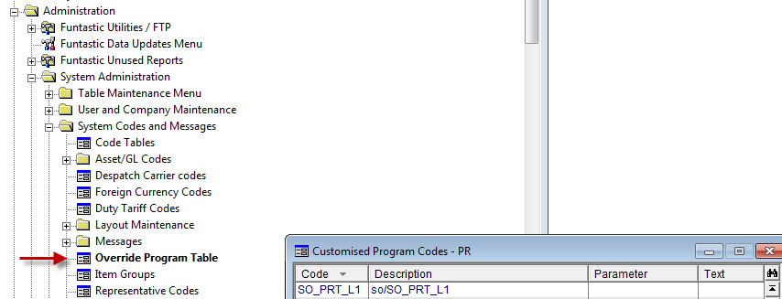
2 – Add field into the layout
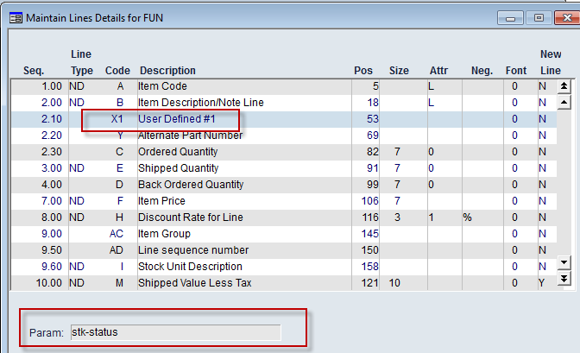

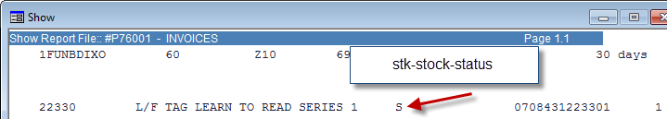
3 – place code below into program called SO_PRT_L1.spl in $CUS/so directory and compile program
//Written by Brian Dixon on 25/6/11
//Generic Program to be used by anyone with a 4GL license.
//Setup needs to be done in 3 stages
//1 - Add entry in override program table (SYS.M359) called SO_PRT_L1.
// - This needs to point to the location of this program. eg. so/SO_PRT_L1
// - Can also use SO_PRT_L2 or SO_PRT_L3.
//2 - Go to procedure called set-invoice-field and add the field you want.
// Also need to define the parameter used in the invoice layout.
//3 - Go to invoice layout -> lines section (SO.M215)
// In the column code enter X1. The parameter field should match the
// field in procedure set-invoice-field. Eg. stk-status
// If SO_PRT_L2 was used then instead of X1 then use code X2.
//
//Optional step: If you want other objects or want to remove objects
//not required then do this in procedure get-object-values
//
//Hint: Look for the tag MARKER to see where to add new fields.
//
//*************************************************************************

procedure main
returning lr-invoice-field pic x(40)
//
local field lf-failed type boolean
//
do get-object-values
returning lf-failed
if not lf-failed
do set-invoice-field
returning lr-invoice-field
endif
endprocedure

procedure get-object-values
returning lr-failed type boolean
//
//
set lr-failed = TRUE //Is set to FALSE at the end of this procedure
get sales-order
on index so-order-no so-bo-suffix
key is num(get-param(1)) get-param(2)
on error
exit
endon
get sales-order-line
on index so-order-no so-bo-suffix sol-line-seq
key is so-order-no so-bo-suffix num(get-param(3))
on error
exit //Only exit on sales order line and header.
endon
if sol-line-type in {'SN' 'KN'}
get stock-master
on index stock-code
key is stock-code
on error
endon
endif
get deb-master
on index accountcode
key is so-cust-code
on error
endon
//
//MARKER: Add any extra objects you want here
//
set lr-failed = FALSE
endprocedure

procedure set-invoice-field
returning lr-print-me pic x(40)
//
local field lf-field pic x(20)
//
set lf-field = get-param(6) //Parameter defined in the invoice layout

switch lf-field
case 'stk-status'
if sol-line-type in {'SN' 'KN'}
set lr-print-me = stk-stock-status
endif
endswitch
endprocedure

